**Documentation**

1. I created a project named **MyFirstMSTestProject** in VS2010 and renamed the form **frmCalculateAmount.cs**
2. Design the frmCalculateAmount form with 04 Lebels one Panel 03 Text Boxes and 02 Buttons.

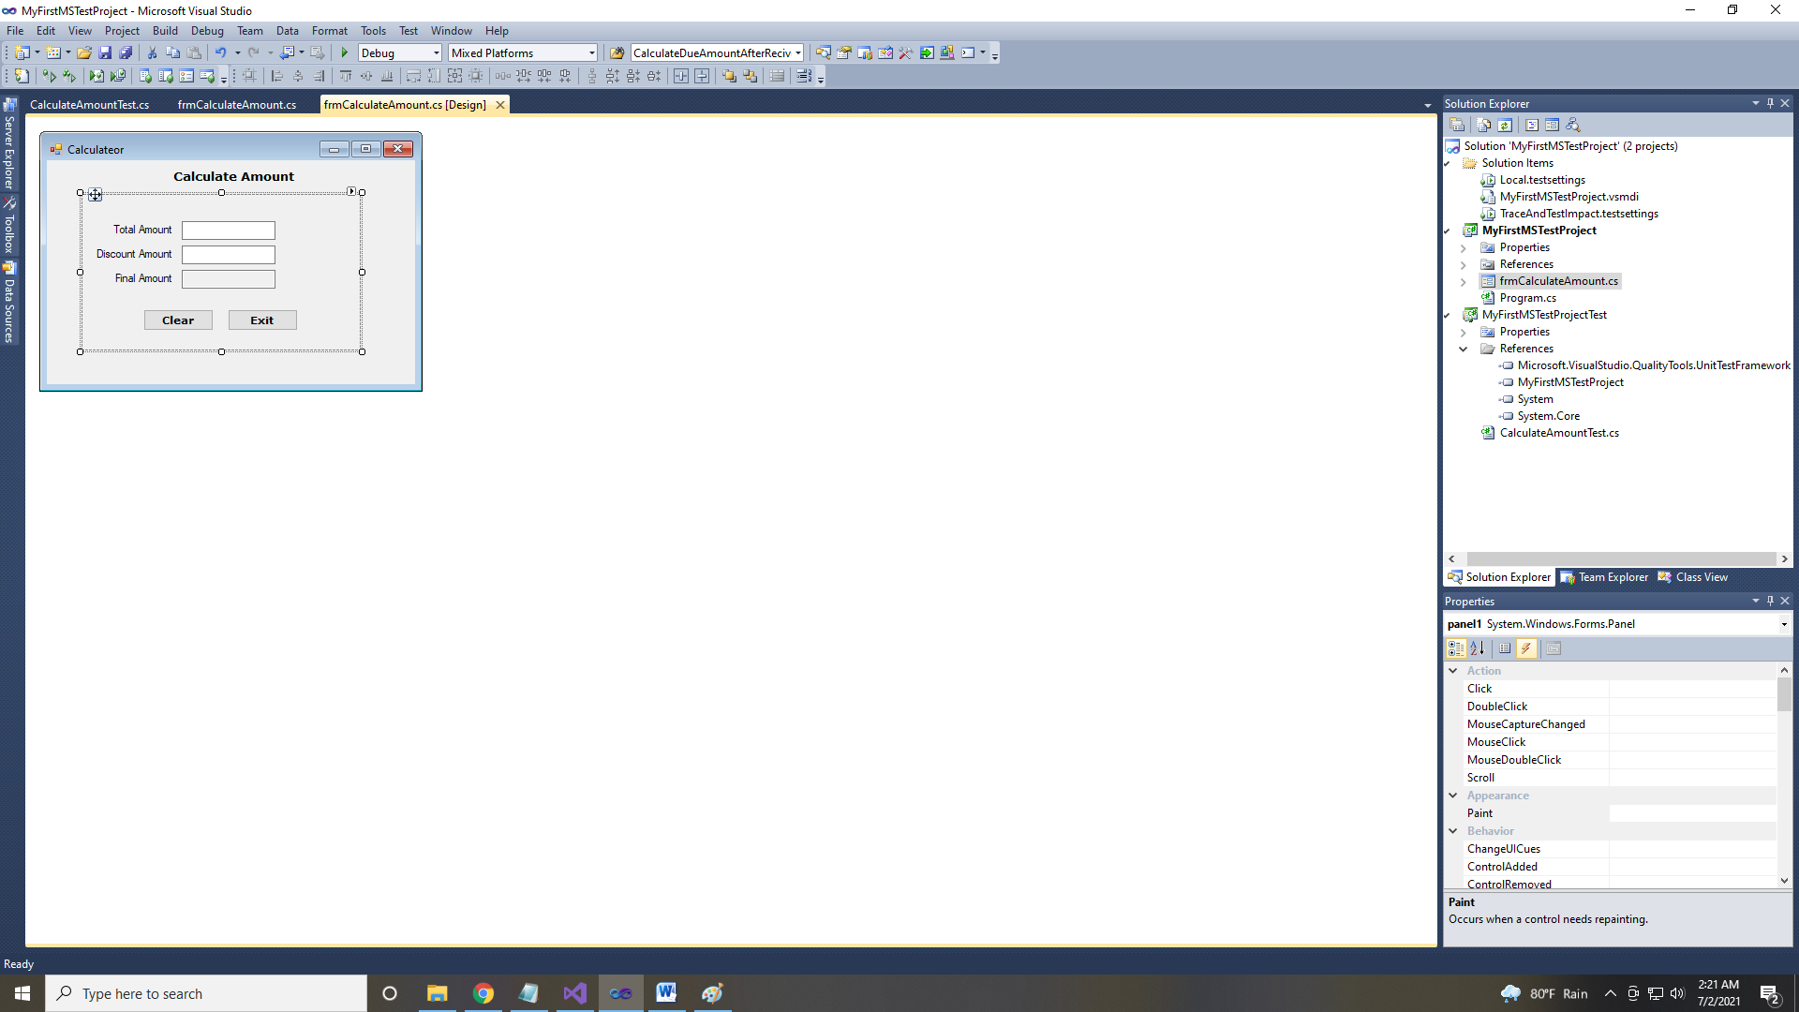

1. Create a method called Create a method called **CalculateAmountAfterDiscount()**  which calculate Final Amount after Deduct Discount Amount from Total Amount Text Box.

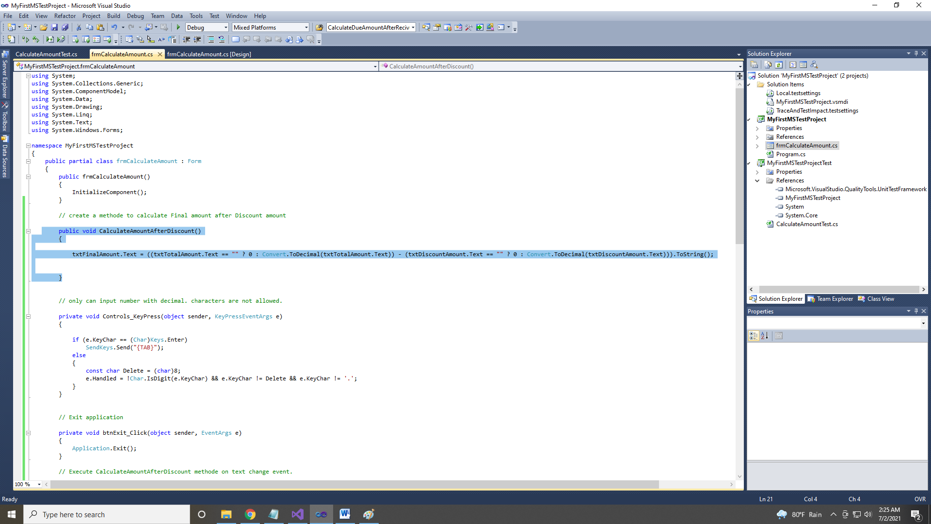

1. To check the method I add a Test project named **MyFirstMSTestProjectTest** and create a test class named **CalculateAmountTest.cs.**

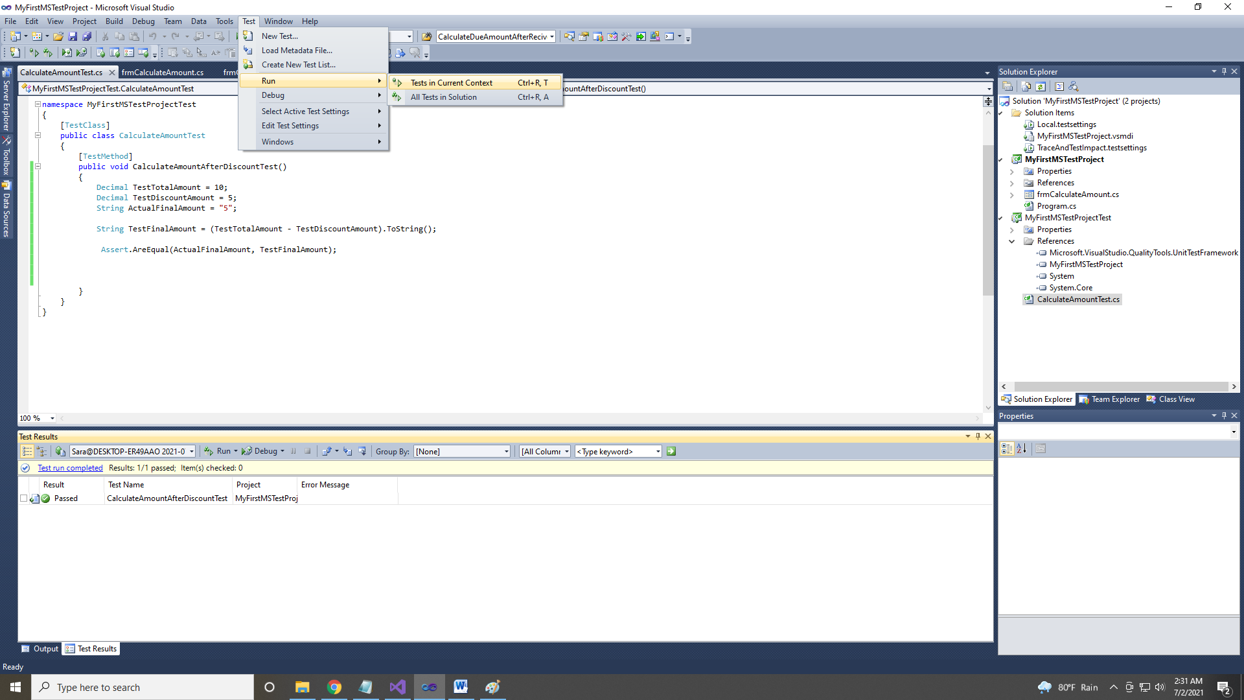

1. Here I add the **frmCalculateAmount.cs** class to References and create a method named **CalculateAmountAfterDiscount()** and test the method successfully.